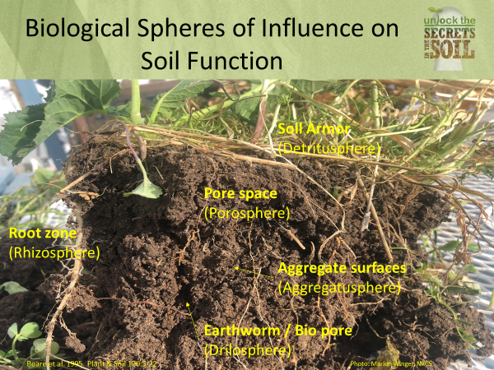

Notes: one of the best soil health diagnostic tools is the … shovel!
To begin to understand how to evaluate the health of a soil from a biological perspective, we need to change our view on how soil functions. Instead of looking at soil profiles, texture and inherent properties, we need to look at the biological processes or spheres of influence that are taking place, synergistic working together in the soil ecosystem.
This information is taken from several sources“A hierarchical approach to evaluating the significance of soil biodiversity to biogeochemical cycling” by M.H. Beare. Some direct quotations from the paper:
• Soils can be viewed as being composed of a number of biologically relevant spheres of influence that define much of their spatial and temporal heterogeneity.
• They are formed and maintained by biological influences that operate at different spatial and temporal scales. Although not mutually exclusive, each sphere has fairly distinct properties that regulate the interactions among organisms and the biogeochemical processes that they mediate.
• Probably more than any other biological factor, the composition and structure of plant communities determine, directly or indirectly, the physical, chemical and biological properties of soils. Individual plants can have markedly different zones of influence in soils.

Spheres of influence (biological processes)

- Detritusphere - Soil Armor
  - Protects soil aggregates from wide shifts in temperature and moisture
• Lowers temperture and reduces evaporation by providing armor to the soil surface
• Provides habitat and feeds the soil organisms
• Enhances biogeochemical nutrient cycling
• Builds soil structure and provides nutrient reserves
- Grain for man and stock for the land
If you don’t see soil armor, we should ask WHY? Tillage, over grazing or to many low residue crops in the rotation are generally the culprits. The same question, if you see build up of crop residue from previous crop years may indicate a lack of biology and lack of rotational diverstiy.

- Drilosphere - Earthworm Channels / Bio pore
• Redistributes soil armor “carbon” and associated nutrients throughout the soil the profile
• Soils are enriched with N,P, S, Ca and humified organic matter
• Increase water infiltration. Pore continuity from the soil surface to lower soil depths. Rapid infiltration rates.
• Provide a bio pore for plant roots
• Homogenize soil surface. What is a good earthworm count? How many have you seen in a cubic foot? In good healthy soils you should generally see 20 plus worms in a cubic foot.
• Increase bio-diversity in soils. They are a keystone organism, it can mean a functioning soil food web
Worms don’t complain, don’t use diesel, if you feed them and give them habitat they will help modify, regenerate, and cycle nutrients throughout the soil ecosystem

- Porosphere - Pore Spaces
The lungs and circulatory system of the soil:
- Regulates water and air flow into the soil ecosystem
• Impacts N, P Mineralization
• Impacts soil organism bio-mass and diversity
• Site of nutrient exchange
• Site of mycorrhizal entanglement and sequestration of water and nutrients
• Root interface
• Part of the water cycle, it’s not complete until the water infiltrates into the soil

- Rhizosphere - Root sheath
The conduit of life! The liquid carbon pathway
• Narrow region of soil directly around roots
• Living roots release many types of organic materials into the soil ecosystem
- Roots with soil attached means a good interaction with microbes
• Diverse compounds (root exudates) attract bacteria that feed on the proteins & sugars
- Protozoa and nematodes that graze on bacteria are highly concenterated in this sphere
- Biological nutrient cycling and disease suppression needed by plants occurs here

- Aggregatusphere - Aggregate surfaces
- Cottage cheese look in the soil profile, crumbly soil, granular soil structure
  - Labile Carbon – the easy to eat microbial food is protecected on the inside of aggregates (akin to storing food in the pantry for later use)

Lack of good soil aggregation results in compacted soils that:
- Restrict root growth
- Provide poor root zone aeration (disease organisms love low oxygen environments)
- Have poor drainage / reduced water infiltration
Lack of aggregates show symptoms of a disfunctional soil: often lots of tillage (soil disturbance), poor infiltration and fallow in the farming system or overgrazing, no solar panel during the growing season.
- No living root to provide food source, microbes start eating the house down
Soil compaction has always been thought of as a physical soil problem caused by excessive tillage and heavy equipment squeezing the soil pore space. Compaction is actually a result of loss of soil organic matter and destruction of soil aggregates. These need to be replaced in the soil in order to provide a stable soil base in which to produce food & fiber. Soil compaction is a biological problem related to decreased production of polysaccharides and Glycol proteins (glomalin in the soil). Soil compaction is due to a lack of living roots and mycorrhizal fungus in the soil.
How do we improve the function of these spheres of influence? By implementing principles of soil health and understand how soil functions!
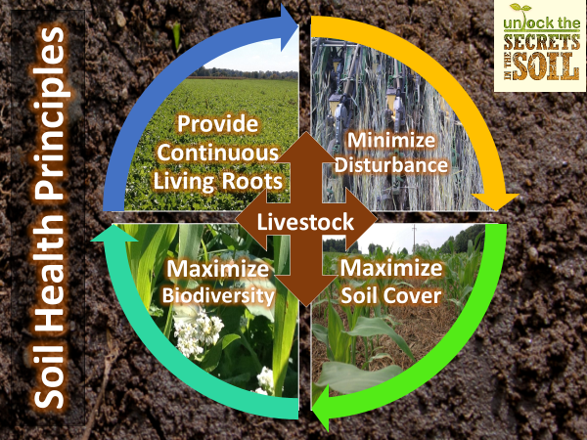

Marlon Winger
USDA-NRCS Soil Health Division MT, ID & WY
References
Kuzyakov, Y. and E. Blagodatskaya. 2015. Microbial hotspots and hot moments in soil: Concept & review. Soil Biol. Biochem. 83: 184-199. doi:10.1016/j.soilbio.2015.01.025.
Beare, M.H., D.C. Coleman, D.A. Crossley, P.F. Hendrix and E.P. Odum. 1995. A hierarchical approach to evaluating the significance of soil biodiversity to biogeochemical cycling. Plant Soil 170: 5-22. doi:10.1007/bf02183051.

